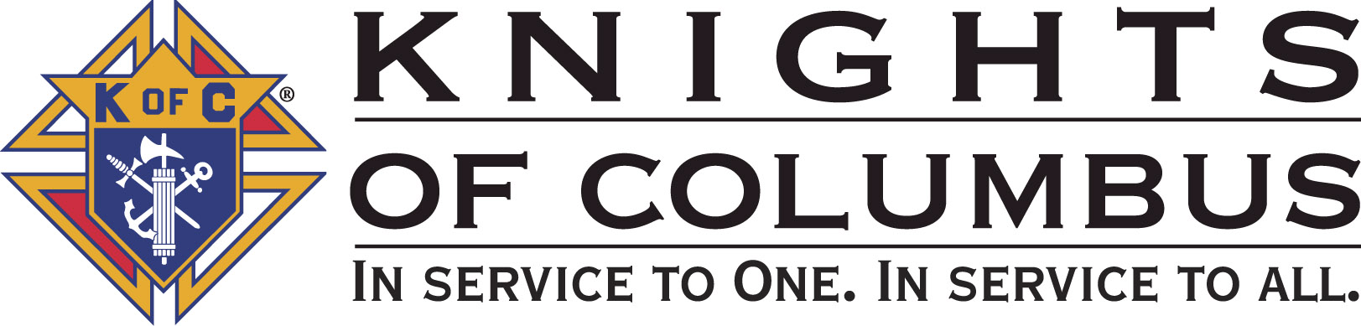

Council #13672 at Divine Savior Fr. Neil W. Seidl
Orangevale, CA
August 2010 Volume 9, #2

Monthly Grand Knight’s Message

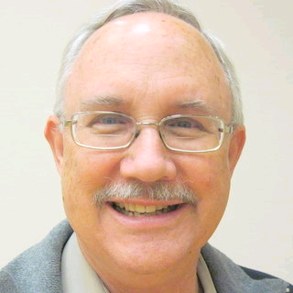

Greetings Brother Knights:
Grand Knight Bruce Pyle

Dep. Grand Knight Tony Aiello

Fin. Secretary Micheal Wagner

Treasurer Allen Brown

Chancellor TBD

Warden Bob Reilly

Advocate Dave Brodie

Recorder Ray Coughlin

Trustee 1st Yr Charlie McDermott

Trustee 2nd Year Bill Windle

Trustee 3rd Year Mike Duskus

Inside Guard Douglas Copley

Outside Guard John Carvalho

Chaplin Fr. Roman Mueller

Lecturer Sam Cimino

Field Agent Tony Magdaleno

The Knights of Columbus Council #13672 at Divine Savior Fr. Neil W. Seidl Chapter meets Monthly on the First Tuesday of each month at 7:00 p.m.
Please join us to help our Catholic Community.
For insurance needs, please contact our Field Agent Tony Magdaleno at 470-9205 or by mail at
P.O. Box 2737
Rancho Cordova, CA 95741

Our Calendar may not look very busy this summer; but it’s been a busy month. Besides Treasurefest, what’s been going on?

Tony and I attended the July 17 Chapter meeting. The new Chapter officers for the next year were installed in a very nice ceremony conducted by the State Treasurer, Ray Warriner. The Northern California Chapter encompasses the area from Sacramento to Oregon Border, and Nevada to the Coast Range. There are 13 Districts, including about 65 Councils. The theme? The new Chapter President, Jack Willoughby is looking to make the meetings more interesting, educational and inviting.

We had a meeting of the Program Directors on the 20th to discuss the calendar and share ideas for the next year. Our theme: make the meetings more interesting, educational and inviting.

On the 21st, Tony and I attended the District 6 meeting, headed by Don Harmata, DD. Chapter President, Jack Willoughby also attended! There are 5 councils in the District (Orangevale, Sacto, Roseville). Again, the theme is one of moving forward, sharing ideas, and to make the meetings more interesting, educational and inviting.

There were other meetings: Tony, Mike, Bill, Jack, Tom…. And talking with the Parish staff… and the phone calls… My wife already wonders if I’ll have a life beyond the Knights. It’s going to be a very busy, rewarding and enjoyable year.

And what’s coming up?

Meeting with the State Deputy on the 24th. Brother Ivan Reek is head of state, and has about 586 councils. We’re meeting at Newman Court. Anyone want to go with us?

Next officer’s meeting on the 26th. 7:00, hospitality room. We cover plans/events/activities/calendar/budget in detail. All invited.

Strategic planning meeting for Tony, me, and select officers and Trustees on the 28th. Also, 1st degree on the 28th. Next General meeting, Sept 7. There’s plenty going on. Feel free to get involved.

I do have some expectations:

I’d like short, effective meetings. I’d like to adjourn by 8:00, but I think 8:15 is more realistic if we include some more informational/educational segments.

I’d like each speaker to be brief. Program Directors in particular should summarize their activities. Full details are discussed in committee meetings and at the officer/planning meeting held the last Thursday of the month (7 pm, hospitality suite). If you want to be involved…

I’d like all attendees to continue to be ready to start by 7:00. We’ve been good about that—let’s keep it up.

I’d like to see more Knights active at this meeting and at the officers’ meetings. Invite someone you haven’t seen here in a while.

I will try to attend as many degree ceremonies as I can. I especially think that each sponsor should attend his candidate’s 1st degree. Then talk to him often. Invite him to meetings and to get him involved.

We have a few new ideas…

Shirts. Golf/polo shirts with K of C logos. Mike is checking on those for availability and price from an approved supplier

Award certs… When you bring in a new member, you get an award cert worth 500 points on an item “purchased” from Supreme. 500 won’t buy anything, so we’re looking at having those certs retained by the treasurer and turned in for items the council can use.

Final thoughts

I’d like all of us to utilize our time from end of meeting to 9:00, to socialize, chat, share what’s going on… have some Unity-Fraternity-Fun in a social atmosphere. It’s a good time to work out the details of some of our events and to talk with those involved.

Most of all, I want us to continue to do good things, but perhaps above all, to have fun doing it. I welcome your ideas.

God bless us all.

Fraternally yours,

Bruce Pyle,
Grand Knight
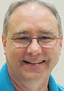

Treasurer Report
(Presented by Allen Brown)

KOC Council No. 132672 – Date balanced: 8/10/2010

Business: $16,301.95
CD50 - 52: $3,243.02
Charity: $711.64
Total: $20,256.61

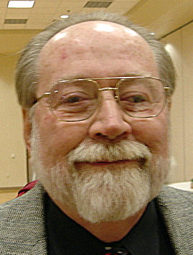

Financial Secretary’s Corner
(Presented by Michael Wagner)

Batch 54 $2000.00 (Charity Account)
Charity Account Funding $2000.00
Batch 55 $863.66
Raffle $43.00
Fireworks Booth $193.00
Social: Recognition Dinner $40.00
Dues $35.50
Event: Recycle Day $552.16
Grand Total $2863.66


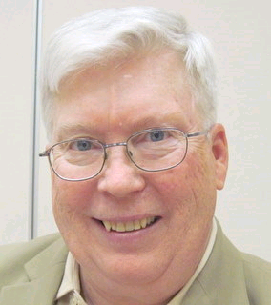
Recorder’s Motions
(As presented by Ray Coughlin)

Motions for August

At the August 10th general membership meeting, the following motions were approved: the monthly bills presented to the Trustees, two new applications and one transferee to our Council, and the Council's budget for the present Columbian year.

Knight of the Month
(Presented by Bruce Pyle)
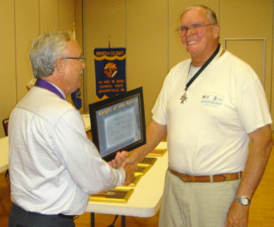

Our Knight of the Month for August is Jack Hill.

Families of the Month

(Presented by Bruce Pyle)

Family of the month for August will be announced in September.

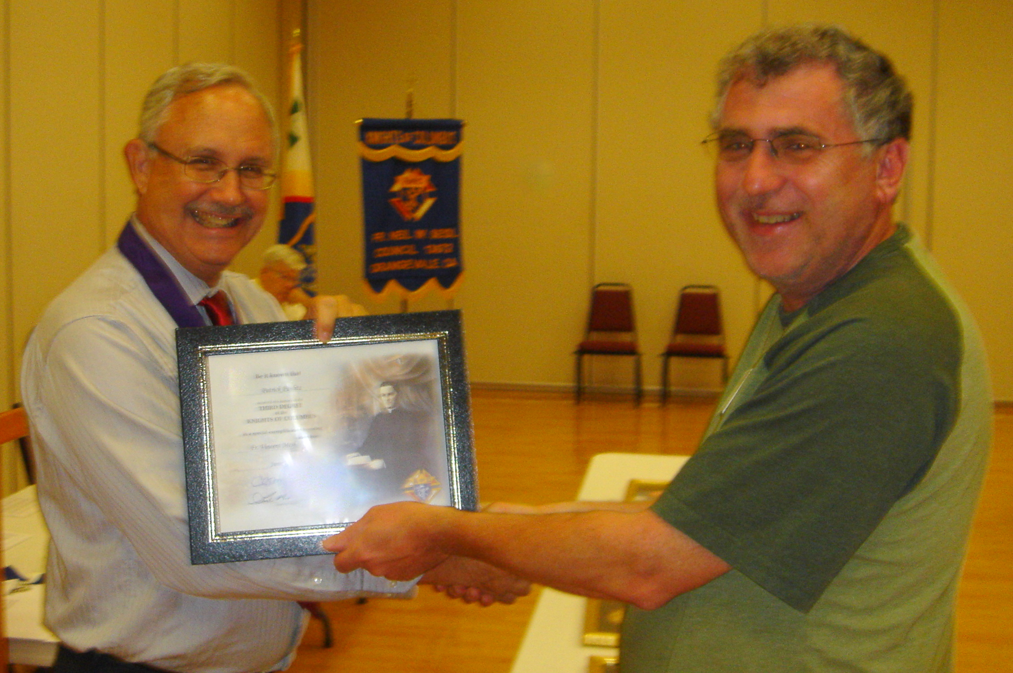

Third Degree Certificate

(Presented by Bruce Pyle)

Patrick Paulitz recently attended the Third Degree seminar.

Congratulations Patrick earning and receiving your Third Degree.

Special Thanks

(Presented by Bruce Pyle)

I wish to thank several people who “stepped up” this month.
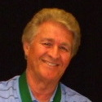
Thanks to: Sam Cimino, our Lecturer. We haven’t had an active lecturer in the past, but it’s time. The Lecturer’s appointment… from the constitution: “shall endeavor to devise means to entertain his council at meetings and perform such duties as his council may direct.” He’s off the hook this month; but next month we’ll help him come up with something.

Thanks to: Tom Hogan for accepting the position of Program Director—Community (vacated by Tony Aiello). Tom is already on the Chamber of Commerce mailing list and will be looking for ways to involve the council in the community. Tom will continue as our Sunshine committee.

Thanks to: Jack Hill for accepting the nomination for Chancellor (vacated by Tom Hogan). Chancellor shall “assist the GK and the DGK in the performance of their duties and shall take charge of the council during the incapacity or extended absence of both.” And he helps get people involved/active in the council and has to say, “nothing to report.”

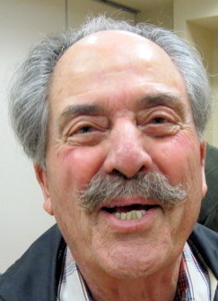
Thanks to: Doug Copley and Bill Windle who will co-chair our pancake breakfasts. The next being Sept 19.

Thanks to: Doug and John Carvalho for room set up.

Thanks to: Mike Wagner for keeping our reports up to date—always meeting the deadlines. This month, audit of the books and report to the IRS.

Special Election

For position of Chancellor

Tom Hogan moved to Program Director, Community

So, from the K of C constitution…

Chancellor shall “assist the GK and the DGK in the performance of their duties and shall take charge of the council during the incapacity or extended absence of both.” And he helps get people involved/active in the council and each month has to say, “nothing to report.”

I relinquish control of the meeting, temporarily to our Advocate Dave Brodie.

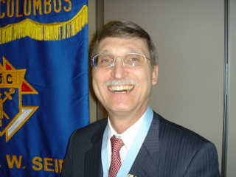

District Deputy News
(Presented by Don Harmata, District Warden)

No new District information at this time

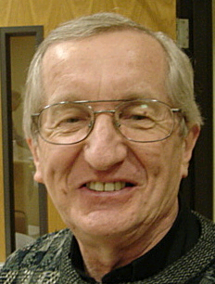
Reflections from the Chaplain
(Fr. Roman Mueller, SDS)

There are no reflections for this month.

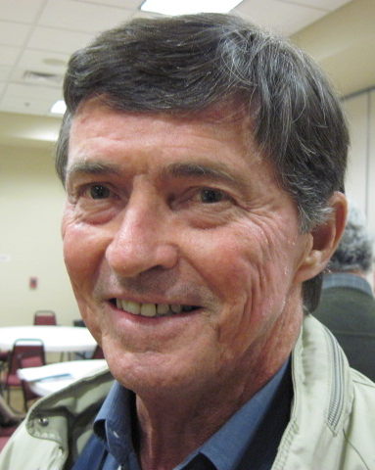
Let the Sunshine
(As presented by Tom Hogan)

Cards are available to be sent out to members and families in need. For future need, please remember to contact Tom Hogan with any sunshine activity or prayer cards that need to be sent.

You can contact Tom at 916-988-2184 or 1mosel@comcast.net.

Remember that we really don’t know how far a little kindness will go.

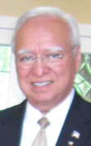
District Insurance News
(Presented by Tony Magdaleno)
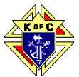

KNIGHTS OF COLUMBUS INSURANCE
KNIGHTS OF COLUMBUS INSURANCE
“YOUR SHIELD FOR LIFE”

Is having “through work” insurance lasting protection?
Do you know anyone whose life has been drastically changed by the recent recession and economic downturn? With unemployment numbers rising, (From the Bureau of Labor Statistics, the unemployment rate in the United States is currently 9.7%), it’s very likely that someone in your immediate or extended family or group of friends is facing financial uncertainty now. With this uncertainty, there is a real possibility that you (or your spouse) could lose your job or change employers.
Too many people have often relied on group term life insurance as their only safety net. Often, this insurance is an employee benefit provided at low or no cost. The existence of this coverage might convince someone that a personally owned life insurance policy is not necessary. Only having “through work” insurance may not work. Most forms of group life insurance are limited in amount, which may be tied to salary or some other benchmark. These numbers are often capped, and this cap may be dangerously low for your family’s actual needs. In fact, without a detailed needs analysis, any employer-provided coverage may give you a false sense of security and may be completely unrelated to your family’s needs at death.
In addition, the amount of group insurance offered is almost always reduced, sometimes dramatically, when you retire or taken away completely. With the possibility of these changes on the horizon, you could one day find yourself without coverage, and if your health has changed (which will as you age), you might also find yourself unable to secure individual protection.
While group life insurance can help, it does not replace the need for individually owned life insurance. I’ll be happy to meet with you and provide a no-cost needs analysis, so you’ll know exactly where you stand.
Please call (916) 470-9205 or e-mail me at tony.magdaleno@kofc.org with any questions you may have. I’m your full time Field Agent…

Fraternally, Your Brother,
Tony Magdaleno
FA # 14661
CA Lic. # OG27147

Committee Report - Membership
(Presented by Ray Coughlin)

Our membership tally is now at 129 members.

If you know of someone who would like to join our council, please refer them to Ray Coughlin at (916) 989-4226 or Tony Magdaleno at (916) 470-9205.

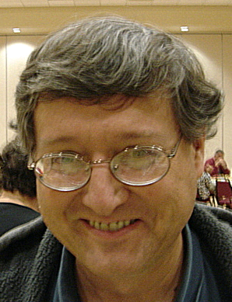

Committee Report - Youth
(Presented by Bill Manos)

Soccer challenge to be held on Sat. September 11th at St. John’s in Folsom. Bill could use more names to qualify for Scholarships, give him a call for details.
Please contact Bill Manos at 965-3834 with any Youth Service Program questions

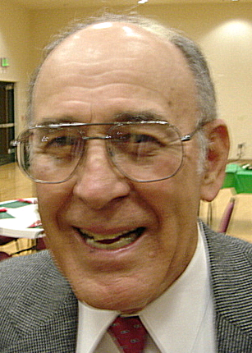

Committee Report - Family
(Presented by Guy Sanchez)

No upcoming activities at this time.
.
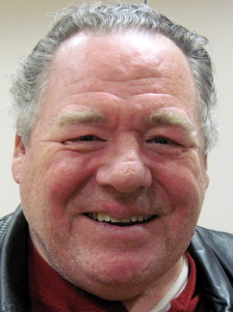
Please contact Guy Sanchez at 965-3834 with any Family Service Program questions.

Committee Report – Council
(Presented by Bill Windle)

Our next pancake breakfast and blood drive will be Sept. 19. Doug Copley has agreed to co-chair this one. We are seeking another co-chair.

Dennis Harrington and his team are working on our website (which will feature… pictures!). We are looking for members with website building experience who would like to involved with the website creation. Please contact Dennis if you are interested in participating (772-4168).

Please contact Bill Windle at 988-2239 with Council Service Program questions.

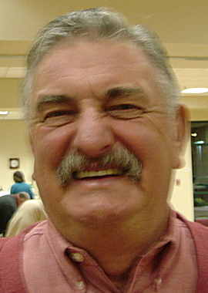

Committee Report – Church
(Presented by Dan Freeman)

An Oktoberfest is being planned for Saturday September 18th in our community hall. Allen Brown is chairing this fun event and he will have signup sheets for the various committees at our next general meeting on September 7th.On September 11-12 we will be helping at this year’s Mather air show, Joe Luchi is chairing this again this year. Treasure fest was a Hugh success this year with the help of many of our brothers and their families.

Please contact Dan Freeman at 987-0908 with any Church Service Program questions.

Committee Report - Community
(Presented by Tom Hogan)

Blood drive and breakfast will be on September 19th. Great breakfast will be $7.00/ adult, $3.00 /children and $17.00/family, serving from 8:00am till noon.

Please contact Tom Hogan at 988-2184 with any Community/Pro-life Service Program questions

Future Council Planning Report
(Presented by Bruce Pyle)

Our new officers will have a Strategic Planning meeting will be held on Sat. September 25th, starting at 9:00 am and chaired by Dan Freeman.


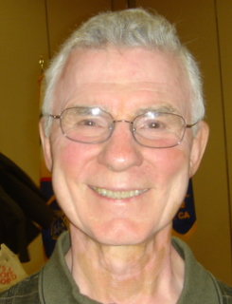

Committee Report – Culture of Life
(Presented by Mike Schaefer)

PRO-LIFE NEWS & ACTIVITIES for AUGUST 2010

As Knights are truly a Pro-Life organization, please participate, and invite others to join you, in a PL activity this month and the days ahead.

It has been determined that 37% of women having abortions are Protestants and 28% are Catholic. This means 65% of women having abortions are Christians!! Therefore, if Christians stop having abortions, Planned Parenthood would be facing bankruptcy; and $23+ million of our CA state tax dollars spent each year to pay for 80,000 "free" abortions could be used for better purposes. Be a Voice for Life and contact your assemblyperson and tell him/her your thoughts on pro-life and how to cut the State’s deficit.

There are still two workshops remaining of four scheduled titled, STOPPING PLANNED PARENTHOOD which is being presented by Jim Sedlak, American Life League, and David Bereit, founder of 40 Days for Life. They are being held in the large conference room at St Joseph Catholic Church, Auburn, CA on August 10 and September 14 (2nd Tuesday of the month) at 7:00pm. (Call Penny @ 530-885-9055)

Plan to attend the Bishop Gallegos Maternity Home Annual Fund Raising Dinner on September 26 at the Dante Club on Fair Oaks Blvd starting at 5:00pm. Fr Patrick Lee will be honored for his pro-life activities. (Call Kathy @ 916-337-6824)

The KCs will hold their 6th annual Chili Cook off at Newman Center Court near Sac State on October 2nd to benefit both the Bishop Gallegos maternity Home and the Sacramento Life Center.

40 Days-For-Life is scheduled for September 22nd to October 31st. Our Council will be represented each Friday at one of the abortion clinics in our area to pray the Rosary to end abortions. More will be reported next month.

The Sacramento Life Center will hold their Salute To Life Dinner & Auction on Saturday November 13. (Please call 916-451-4357 for information.)

A Pro-Life Mass is held monthly (2nd Tuesday @ 6:00pm) at St Philomene’s 2428 Bell Ave. The next Mass will be August 10th. (Call Sally @ 916-721-0378)

Any questions to the above can be addressed to Mike Schaefer at 916/988-3171.

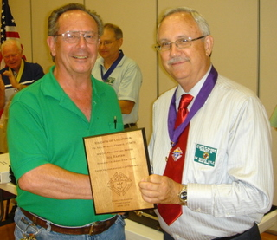
Special Thanks

During our July meeting Joe received a Special Recognition Award for his outstanding service for Divine Savior Pancake Breakfast. Thanks Joe for making a difference!

Special Prayer Intentions

Please keep the following people in your prayers:

- Zoe Mann- wife of Steve (Kidney removal)
- Tom Lawson (cancer)
- Rich Dean (chemo- cancer)
- Mary Trujillo- wife of Peter (asthma)
- Peter Burriesce (dialysis/foot healing)
- Denise Ash- sister of Bill Wagner (cancer)
- April Paulitz- wife of Patrick (cancer)
- Debbie McDermott- wife of Charlie McDermott (dementia)
- Julia Rapier- mother of Joe Rapier (memory)
- Sick: Barbara Lawson, Paul Pyle, Ladene Carvalho, Eldon Hancock,
Earl Varney, Martin Jennings, Jack Joiner and Beverly Ridge
- Deceased: Frank Stuto- father of Tom & Barbara Lawson
- Deceased: Robert Howe

August / September Birthday List


James Morgan | 5-Aug
Donald (Don) Marnach | 6-Aug
David Noble | 8-Aug
Arturo (Art) Reyes | 8-Aug
Ryan Mascarenhas | 11-Aug
John Mercurio Sr | 20-Aug
Michael (Mike) Duskus | 31-Aug
Joseph (Joe) Paddock | 3-Sep
Curt Taras | 7-Sep
David Chacon | 8-Sep
Thomas Sekel | 10-Sep
Anthony (Tony) Aiello | 12-Sep
Wm Presley King | 12-Sep
Thomas Hogan | 13-Sep
Jeffrey Mangum | 17-Sep
Patrick Paulitz | 18-Sep
Simon Herrman | 22-Sep
John Ledesma | 24-Sep
George Zettel | 26-Sep
Marc Pascual | 28-Sep
We would like to wish each of the members listed a Happy Birthday!!!

Calendar of Events

Date | Event | Day/Time | Location
Jun 28-July 4 | Fireworks | 9a-9p plus setup/close | Cable Park,  Grnback+Filbert
July 6 | General Meeting | Tues 7:00 | DS Parish Hall
Moved to Aug. | Annual Planning |  | DS Conf Rm
July 22 | Officers/Planning | Thurs 7:00 | DS Parish Hall
Aug 3 | General Meeting | Tues 7:00 | DS Parish Hall
Aug 26 | Officers/Planning | Thurs 7:00 | DS Parish Hall
Sept 7 | General Meeting | Tues 7:00 | DS Parish Hall
Sep 11-12 | Mather Air Show | Sat-Sun | Mather
Sep 11 | 2nd and 3rd Degree | Sat | West Sac
Sep 18 | Oktoberfest | Sat | DS Parish Hall
Sept 23 | Officers/Planning | Thurs 7:00 | DS Parish Hall
Oct 5 | General Meeting | Tues 7:00 | DS Parish Hall
Moved (tbd) | Recycle Event | Sat 10-2 | DS Parking lot
Oct 15-17 | IR (Tootsie Roll) |  | 2 locations
Oct 17 | Soccer Challenge | Sat 11-3 | St. John Baptist
Oct 28 | Officers/Planning | Thurs 7:00 | DS Parish Hall
Nov 2 | General Meeting | Tues 7:00 | DS Parish Hall
Nov 18 | Officers/Planning | Thurs 7:00 | DS Parish Hall
Nov 21 | Corp. Communion  Memorial Mass | Sun 7:45 | Church
Dec 3 | Christmas Social | Friday | DS Parish Hall
Dec 7 | General Meeting | Tues 7:00 | DS Parish Hall
Dec 16 | Officers/Planning | Thurs 7:00 | DS Parish Hall

